**PROPERTY ANALYSIS BI DEVELOPER- STANDARD SPRINT - PART 1**

**SAMPLE DATA OF STANDARDIZED DATASET**

**Standardize Dataset for Suburbs (Total Rows: 16,078)**

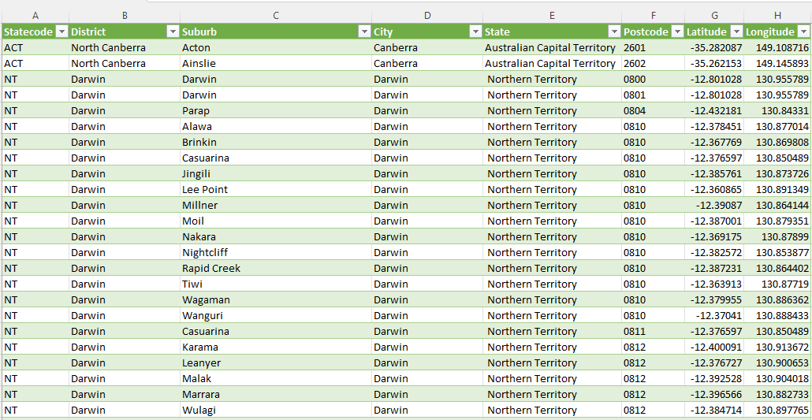

**Given raw dataset, standardize datasets for public transport in Australia (Total Rows: 68,779)**

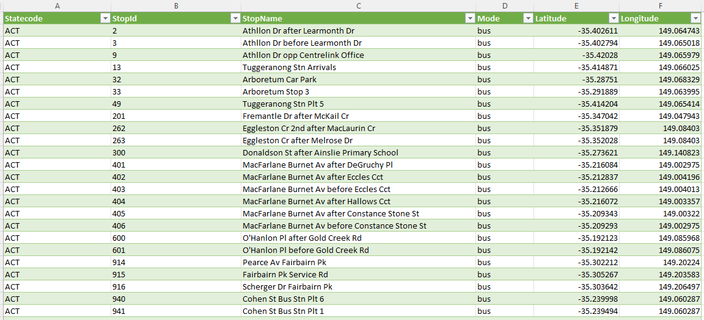

**Given raw dataset, standardize datasets for local school (Total Rows: 8,184)**

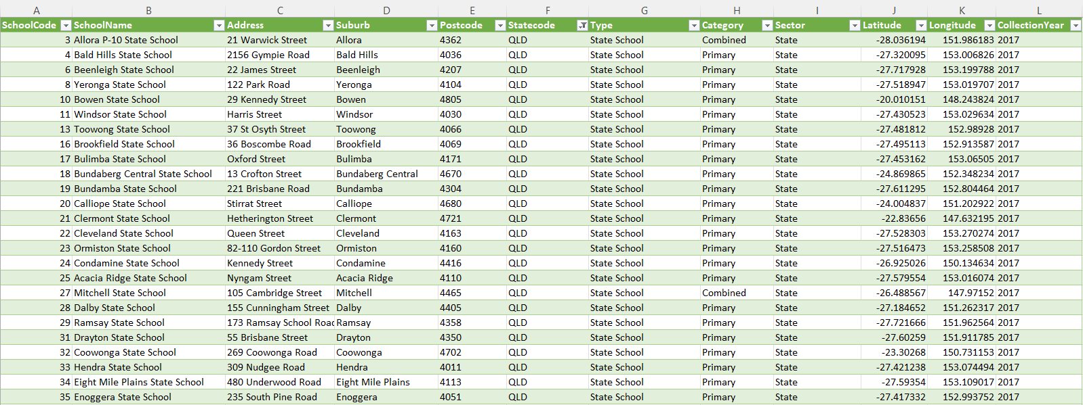

**Given raw dataset, standardize dataset for Rental Median per Suburb, City (Total Rows: 19,130)**

**Given raw dataset, standardize the dataset for Median Property Value per Suburb (Total Rows: 7,087)**

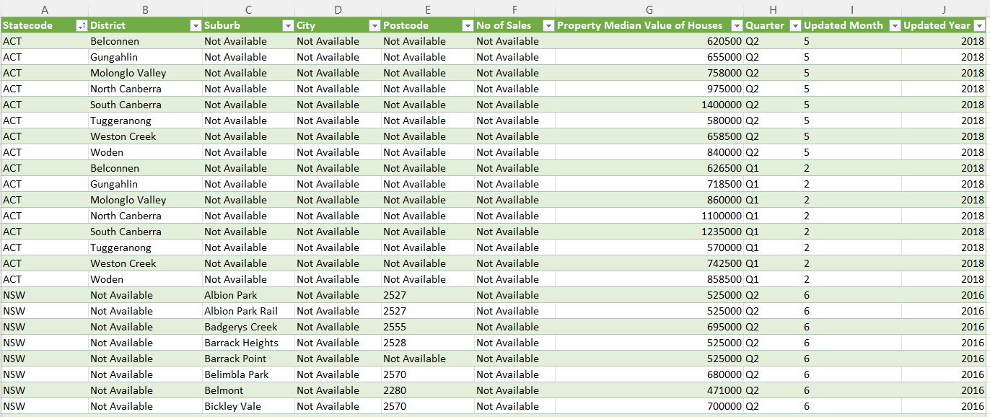

**Given raw dataset, standardize the dataset for crime rate of each suburb and city (Total Rows: 66,041)**

